There will be flowers available onsite.
You can also pre-order! Click on the link for the price that you want under each photo to pre-pay. Please include your name and phone number so that we know who will come by the flower stand at CIC to pick up your skater’s bouquet!
If you wish something other than what you see here please call Roxanne at 425-255-8693

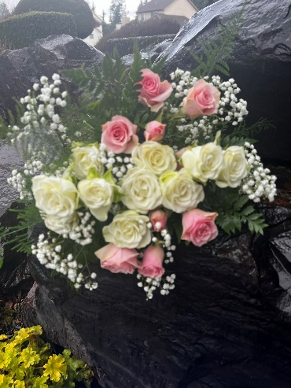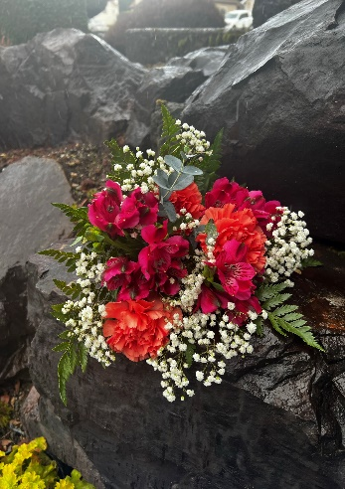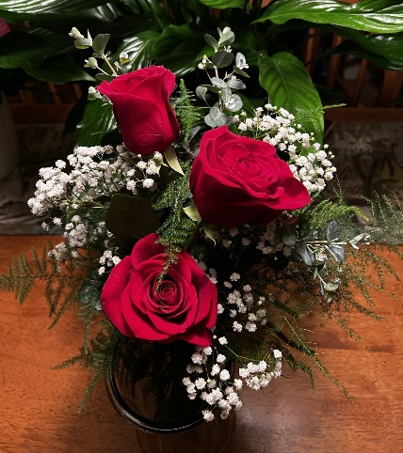
Pink & White Spray Roses Carnations & Alstroemeria 3 Red Roses $20.00
$20.00/$25.00 $20.00/$25.00 Single Red Rose $7.00
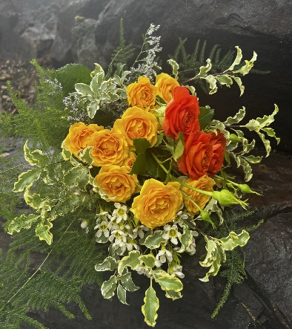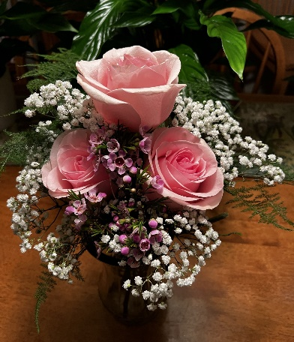
Hydrangea & Alstroemeria Orange & Yellow Spray Roses 3 Pink Roses $ 20.00
$20.00/$25.00 $20.00/$25.00 Single Pink Rose $7.00

