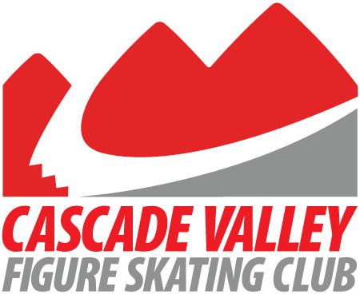

IJS Protocol for Test Credit Request Form
Athletes’ Name: Alice Zhou
USFSA Member #: 6764519
Parent: Yuling Zhou
E-mail Contact: yuling_zhou@hotmail.com
Phone Contact: 425-830-0619

Requesting Test Credit for: Intermediate FS

Coaches Name: Lisa Bell
E-mail Contact: lisabellice@gmail.com
Phone Contact: 917-753-8690

I verify that the athlete listed above is eligible to receive Test Credit through IJS protocol. I have seen the unaltered and correct scores, which match the protocol the athlete is submitting. I understand that altering a protocol sheet to meet the test requirement is considered an ethics violation of U.S. Figure Skating and The Professional Skaters Association.

Coaches Signature:
USFSA #: 530051
PSA #:
Name of Competition: 2018 May Blades, Lakewood Winter Club
Date of Competition: Friday, May 18 - Sunday, May 20, 2018

Please submit copy to CVFSC Board of Directors for our records

