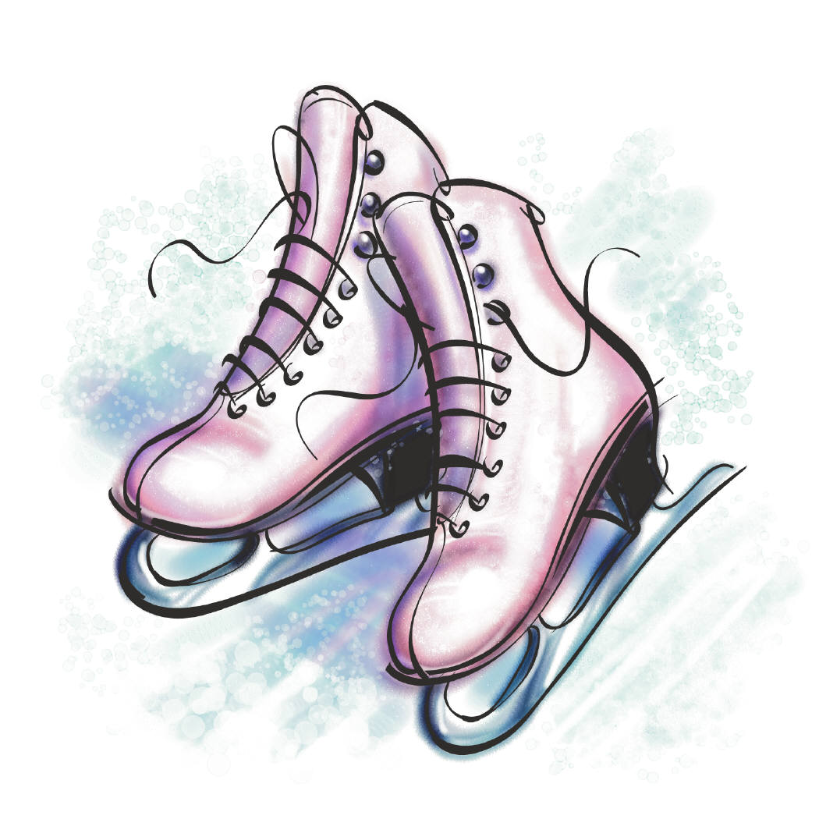
Cascade Valley Figure Skating Club
2019 Dress Swap
in conjunction with
National Skate Month Celebration

Friday January 25, 2019
4:30 - 6:00 PM

Annual Dress Swap

*Please read through the attached information for complete details and forms for Dress Swap.
Open to:
All CVFSC members
Private basic skill skaters
SnoKing Renton Bridge Class students

For more info visit www.cascadevalleyskating.com and our Facebook page. For questions contact CascadeValleyFSC@yahoo.com.

The following items may be offered for sale:
- Competition Dresses / Pants / Shirts
- Practice Dresses
- Skating Skirts
- Unused, Unopened Tights & Skating Socks
- Zuca Bag Frames, Inserts & Seat Cushions
- Unused, Unopened Skate Guards & Soakers

Please note that we are not able to accept new or used skates, skate boots, or blades for this sale

How to Participate as a Seller

- Fill out the “Dress Swap Seller Registration Form” (page 3), “Itemized List of Swap Items” (page 4) and specific labels for each item (page 5). Please match inventory numbers on the labels to the inventory # on your “Itemized List of Swap Items” form.
- Print specific labels (page 5) for swap items and attach the specific label to the swap item. Must use safety pins to secure label. Do not include hangers.
- Please secure in ONE bag large enough to accommodate and include:
1) Dress Swap Seller Registration form
2) Itemized List of Swap Items form
3) All swap items with respective labels
- Drop off your items using the 2 options below:
- To your coaches: You can drop off your bag of items to your coach between Monday, January 21st and noon on Wednesday, January 23rd. Please try to make sure everything is in ONE bag large enough to accommodate all. If you need to have more than one bag, please make sure to have a copy of “Dress Swap Seller Registration Form” and the “Itemized List of Swap Items” in each bag.
- To club board members during freestyle sessions 2:45pm-5:45pm Wednesday January 23rd: a club board member will be in the lobby to collect swap items.
- If you cannot attend the Dress Swap on Friday January 25th, but would still like to sell, please contact CascadeValleyFSC@yahoo.com

- All items not picked up after 7pm the day of the dress swap (January 25th) will be donated.

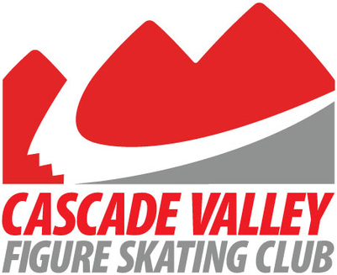

Dress Swap Seller Registration Form
(This form must be filled out by all sellers to participate and will serve as your receipt. Please PRINT)

Seller Name: ______________________Phone #: _________________________

Address (Important for us to mail the check to you):

___________________________________________________________________

Email: ______________________________

- Cascade Valley Figure Skating Club will collect gross sales and summarize total sales per seller using pre-printed sales label. 10% of each sale will be donated to Cascade Valley Figure Skating Club. The remaining 90% will be mailed to each seller within 2 months after the sale.

- Registration form, inventory and labeled items can be dropped off beginning Monday January 21st, 2019. See Step 4 in the page above for details. Items not picked up by 7pm on Friday January 25th will be donated.

- Make sure pre-printed sale label is securely affixed to each item with safety pins or it cannot be sold. Do not provide hangers with dresses. Be prepared prior to dropping items off by filling out ALL paperwork. Complete paperwork on your computer OR printed for legibility. We must be able to read all information.

CVFSC Use Only:
Cascade Valley Figure Skating Club cannot be responsible for lost, damaged, or stolen items.
Gross Sales
Less 10%
Net Check
Check #
Date Mailed

Itemized List of Swap Items

Seller’s Name: ___________________________
Inventory #  (Last Name + #) | Description | Price
Example:  Doe 1 | Competition Dress - red velvet, long sleeve with crystals along neck line; Revella, size youth 12  (you can copy and paste into the label below) | $75.00
Example:  Doe 2 | Practice Dress - blue paisley with solid blue skirt; Jerry, size child 6-8 | $25.00

Please fill out and cut the sale labels and securely attach the label to each item with safety pins or items cannot be sold.

Seller Name: (Example 1) Jane Doe | Seller Name: (Example 2) Jane Doe
Description:  Competition - Red velvet, long sleeve with crystals along neck line; Revella, Size youth 12 | Description:  Practice - blue paisley with solid blue skirt; Jerry, Size Child 6-8
Price: $75.00 | Price: $25.00
Inventory #: Doe 1 | Inventory #: Doe 2
Seller Name: | Seller Name:
Description: | Description:
Price: | Price:
Inventory #: | Inventory #:
Seller Name: | Seller Name:
Description: | Description:
Price: | Price:
Inventory #: | Inventory #:

